**Subject Code: CS 254**

**Digital Systems Laboratory**

**Ex.1 Simplification realization of Boolean expressions using logic gates/universal gates.**

**Aims and Objective**: To simplify the given expression and to realize it using Basic gates and Universal gates.

**Learning objective:**

* To simplify the Boolean expression and to build the logic circuit.
* Given a Truth table to derive the Boolean expressions and build the logic circuit to realize it.

**Components required:**

* IC 7400, IC 7408, IC 7432, IC 7406, IC 7402, Connecting wires, Breadboard.

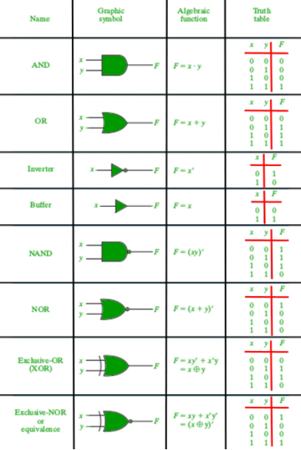

**1.Implementation of AND Gate using Universal gates.**

**a) Using NAND Gates**

The AND gate can be implemented by using two NAND gates in the below fashion:

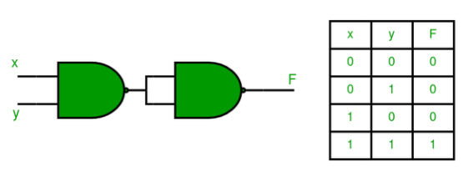

**b) Using NOR Gates**

Implementation of AND gate using only NOR gates as shown below:

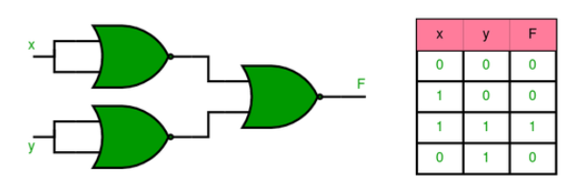

**2. Implementation of OR Gate using Universal gates.**

a) Using NAND Gates

The OR gate can be implemented using the NAND gate below:

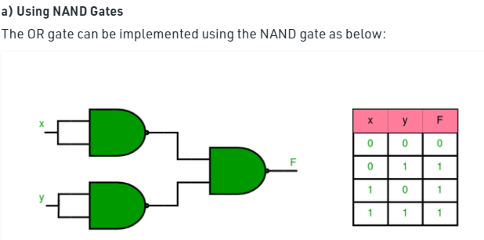

b) Using NOR gates

Implementation of OR gate using two NOR gates as shown below:

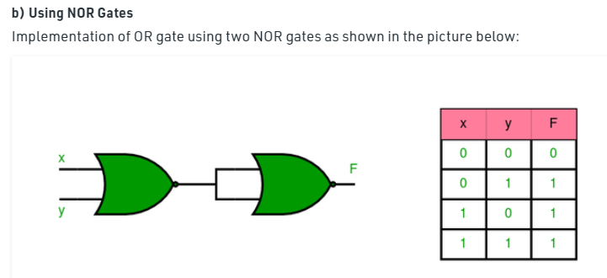

**3. Implementation of NOT Gate using Universal gates.**

**a) Using NAND Gates**

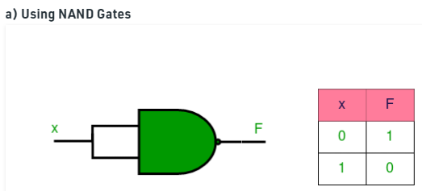

**b) Using NOR Gates**

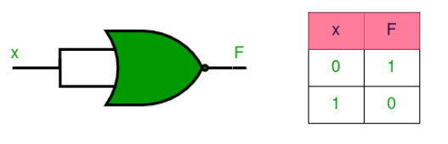

**4. Implementation of XOR Gate using Universal gates.**

**a) Using NAND Gates**

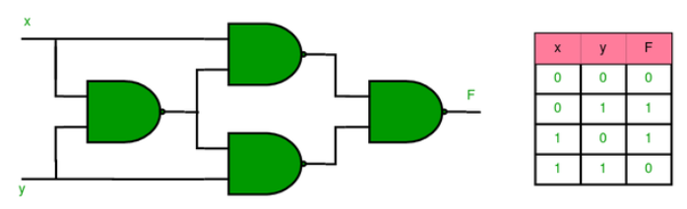

**b) Using NOR Gates**

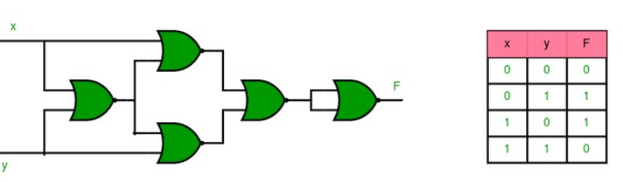

**5. Implementation of XNOR Gate using Universal gates.**

**a) Using NAND Gate**

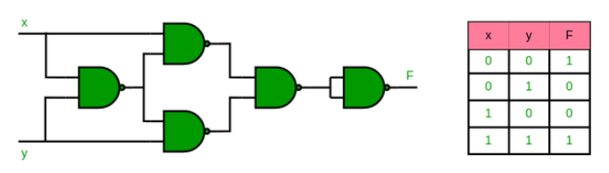

**b) Using NOR Gate**

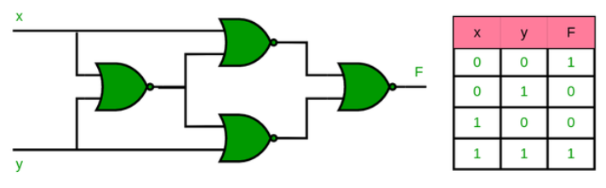

**6. Implementation of NOR Gate using NAND Gates**

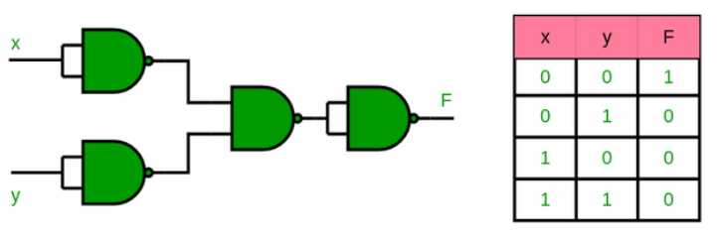

**7. Implementation of NAND Gate using NOR Gates**

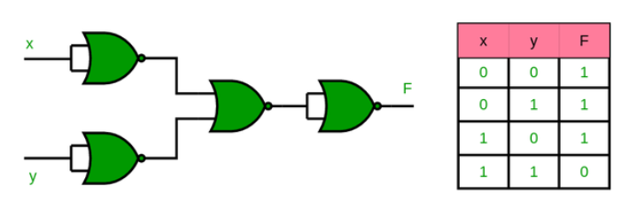

**RESULT:** Simplified and verified the Boolean function using basic gates and universal gates